To Do:
- Three presentations scheduling
- ConOps Editing

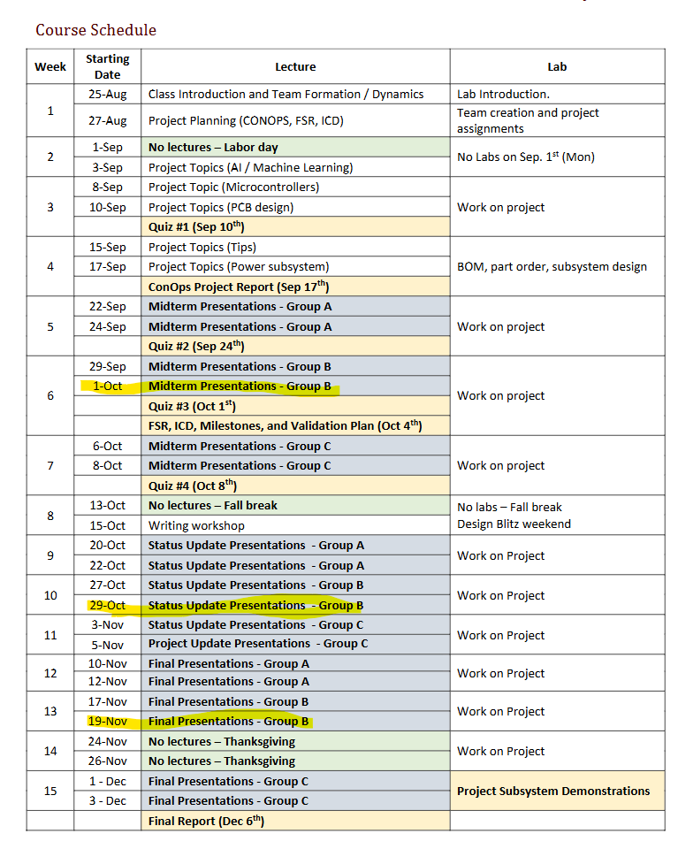

Meeting Notes:

Intro Requirements: This is a summary of your project. What is the problem you are addressing, how are you going about addressing it, what is your execution and validation plan? You must upload your presentation slide deck before your presentation as a PDF.
^ include milestones for each subsystem.

- DAC- Voltage Output, same microcontroller
- MCU… ESP32

Need:
- FPGA… TBD Brayden needs to help!!! By EOD Tuesday
- Lights… Serene Needs to add links for these components!!!
- BNC Jacks… Serene Needs to add links for these components!!!

https://www.espressif.com/sites/default/files/documentation/esp32-wroom-32_datasheet_en.pdf

Parameter | Purpose | Where to Find It | Value
Core Voltage | Power | https://www.espressif.com/sites/default/files/documentation/esp32-wroom-32_datasheet_en.pdf | 3-3.6 (V)
Core Current (Max) | Power | Same | 0.5A minimum
I/O Voltage | Control | Same | VDD
Any Special Rails

FPGA

Parameter | Purpose | Where to Find It | Value
Core Voltage (VCCINT)
Core Current (Max)
I/O Bank Voltages (VCCIO)
I/O Bank Currents
Auxiliary Voltage (VCCAUX)
Auxiliary Current
Power-On / Off Sequence

Memory

Parameter | Purpose | Where to Find It | Value
Type & Part Number
Core Voltage (VDD)
Core Current (Max)
Termination Voltage (VTT)
I/O Voltage (VDDQ)

DAC - TI DAC 8831
https://www.mouser.com/ProductDetail/Texas-Instruments/DAC8831ICD?qs=vul0MlC%2Fa1crLihD5zyKBg%3D%3D

Parameter | Purpose | Where to Find It | Value
Analog Supply Voltage (AVDD/VAA)
Analog Supply Current (I_AVDD)
Digital Supply Voltage (DVDD) |  |  | 2.7-5.5  5 typ
Digital Supply Current (I_DVDD) |  |  | 5uA type  20uA max
Reference Input Voltage (VREF) |  |  | 1.25- VDD  2.5 typ
Reference Input Current (I_VREF)

Analog Output Stage Filters

Parameter | Purpose | Where to Find It | Value
Op-Amp Supply Voltage Range
Op-Amp Supply Current (per amp)
Output Voltage Swing

ZOOM:
https://tamu.zoom.us/j/95484877351

